First Day of Class Ice Breakers and Study Planning: “Being A Math Person”
(This is taken from a math textbook used at Macomb Community College. You may want to adapt this to the expectations or discussions in your own course.)
Hard Work, Tutoring and Study Strategies | Hard Work, Tutoring, and Study Strategies | Hard Work, Tutoring, and Study Strategies
Natural Ability | Natural Ability
 |  | Natural Ability
Time Management | Time Management
 |  | Time Management

- Look at the chart on the page on your handout. The chart highlights some of the ways that “natural ability” does not necessarily translate into grade or aptitude for math. Draw your own chart that includes your natural ability, your previous learning, your previous experiences (and feelings about math).
- Think about the kind of grade you want in this class, and write it down on a sticky note (going around). Put the sticky note on the back page of your textbook. I do not need to see it.
- Keeping the grade from step b in mind and your graph from step a, write out a study plan for the semester. When will you study? How will you study? In the coming week, we will talk about reading and learning strategies, so this is a good place to write down questions you have about how to study, when to study, and what to focus on. (I’ll respond to these in the first two weeks of class, as we develop our course plan.)

Anticipatory Reading at Class Closing: Pretest & Anticipation (15 minutes)
For the last fifteen minutes of class, I’m going to let you get a start on your homework.
- What I want you to do is to take out a clean sheet of paper. Create a table of three columns. Write a list of all of the chapter titles and subtitles in the first column, leaving a line between each in your list.
- In the second column, write down all the knowledge you already have about each of those subsections.
- In the third column, right down questions you have or what you don’t know about this area. This can include “I’ve never heard of this” or “I think this is… but I’m not sure” or any other questions that you have. I will collect this table with the the math problems you will complete for the next class. They will be X% of your homework grade.

Classroom “free-write” concept orientation:
  - Take 5 minutes to list all of the concepts you remember from the chapter you read and worked on for today’s homework. Provide a brief definition for each concept and an example of how you used the concept in your homework for today or in the past. (5 min)
  - Bonus point: offer an example of how you do or could use this concept in the real world.
  - Grading bonus: Pass to a peer. Have peers correct, modify, or expand definitions [using or not using the text]. (5 min)
  - Share out experiences of pairs (5 min)

Homework Assignment: Definition Media & Culture Watch:
Professionals in every discipline develop special language and definitions to refer precisely to the work they do and to avoid confusion when describing complicated ideas to one another. When terms we use in our public lives are used differently for a specialized profession, it can be difficult to move between these definitions, or even to spot the differences. Spend the next week watching the media—TV, Newspapers, radio, Internet sites, and overheard conversations for people using [selected vocabulary: significant/significance, exponential, probability,. . . ] differently from how your book defines it. Name the word, describe how it was used, and explain if the use is confusing or different from how we use it in class. If people on TV or elsewhere are using a term differently than the way mathematicians and statisticians use a term to describe the same thing, what kinds of problems or benefits may result?

Homework Assignment: Definition Research (variation on Culture Watch):
- Check out these online resources on statistics. http://www.statsci.org/teaching.html
- Find definitions for {selected terms} using at least two of these resources. Record the defintions from two of the resources for each of the five selected terms. What differences do you find in the two definitions for each term? Do these differences affect your understanding of the term?
- Now Write your own definition, using these two as jumping off points. Be sure your definition is accurate, but try to use your own words to explain the term. If it helps, you could imagine you are explaining the term to a younger sibling or an older member of your family (like a grand parent).

Homework Assignment: Get Your Geek on:
Below is a comic taken from the xkcd series about a Poisson distribution. Write a short description for why this is funny.
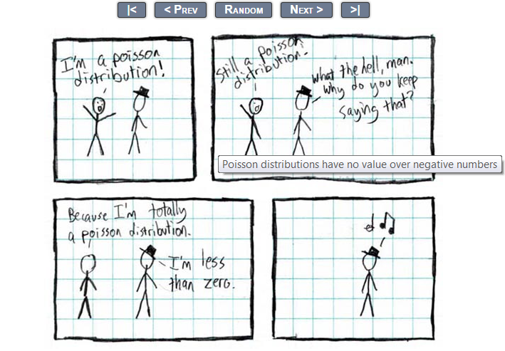
Figure 1: XKCD Comic Series-- Poisson Distribution
Then, go to Google and type in xkcd. Your search results will include a separate search window for XKCD:Advent. (see image) In that search box, enter a vocabulary word from the index provided from the course. Download the image or copy the URL into your homework and explain the comic strip in light of what you know about the term (and how the book defines the term).
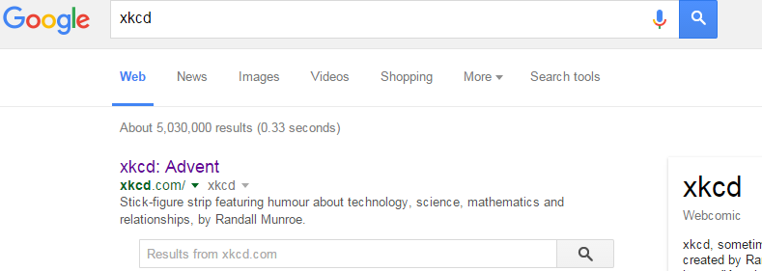
Figure 2: Search XKCD on Google

Semester Project: Build a Wiki:
Have students work in groups in Canvas or on another resource to build a Wiki page that defines the terms of the course. Have them identify key terms and link definitions. Have them develop examples and link to videos where the terms are being used accurately (or inaccurately) as you desire.
*Jon, I am working on this to see if I can build it in Canvas and hand it over to the math department. I am having trouble with my Canvas account. Will follow up.

